**LED Flasher**

Circuit Diagram

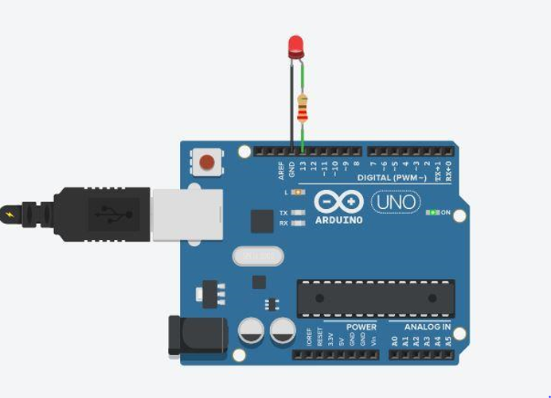

Theory

Concept Used:

We use just a few basic concepts in this experiment which are listed below:

1. Working of the LED

2. Digital Pins of Arduino Uno Circuit Board

3. The code used to program Arduino Uno (micro-controller)

Working of the LED

LEDs are a particular type of diode that converts electrical energy into light. In fact, LED stands for "Light Emitting Diode." LEDs are like tiny light bulbs. LEDs have two terminals. The positive side of the LED is called the "anode" and is marked by having a longer "lead," or leg. The other, negative side of the LED is called the "cathode." Current in LEDs always flows from the anode to the cathode direction.

Digital Pins of Arduino Uno Circuit board

Positive terminal of the LED is connected to Arduino Uno of Output side at digital pin 13 which is programmed to give the digital signal which glow the LED. The negative terminal of the LED is connected to the ground pin of Arduino Uno, to provide a return path way for the current in accomplish to complete the circuit.

The code used to program the Arduino Uno

LED flasher the code provides instructions which results in lighting up of LED for 1 second and then dimming down of the LED for 1 second. This process is repeated to give the effects of Flashing, until the power supply to Arduino stops.

Learning and Observations

In this experiment we learnt the following:

1. Basic circuit building with Arduino uno.

2. Interfacing an LED with Arduino uno.

observations:

1. When the delay was changed from 1000ms to 300ms, the blinking of LED become faster as compared to previous one(delay 1000ms) but still it is observe that it goes turns ON and OFF.

2. When the delay was changed from 300ms to 30ms, then the LED does not blink further, as it appears to stays ON because the changes takes place at that speed can’t be detected by our eye and we see the LED ON only.

Precaution

1. The LED should not be connected in reversed direction because it doesn’t allow passing the current and circuit does not completed and LED will not glow.
2. The led should not be connected to power supply of 5 v directly.

Learning Outcomes

Via this activity we learn and acquire the skills about the following:

1. The application and usage of digital input/output pins of Arduino uno.

2. How LEDs work and their interfacing with Arduino Uno.

3. Understood the syntax to write the basic code in Arduino IDE.

4. How to Identify the P-N Junction of LED.